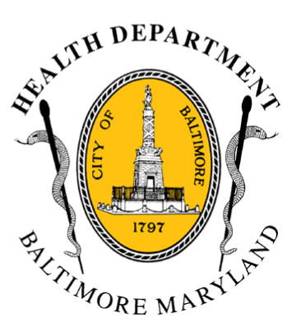

BCHD PRESS RELEASE
Baltimore City Health Department
1001 E. Fayette Street • Baltimore, Maryland 21202
Stephanie Rawlings-Blake, Mayor
Leana Wen, M.D., Commissioner of Health

Media Contact: Michael Schwartzberg, PIO
O: (443) 984-2623 C: (443) 462-7939 E: michael.schwartzberg@baltimorecity.gov

Health Department Working To Provide Access and Information For Critical Health Services, Announces Webpage For Clinical Updates

BALTIMORE, MD (April 30, 2015) – In response to the recent civil unrest in Baltimore, Mayor Stephanie Rawlings-Blake and Baltimore Health Commissioner Dr. Leana Wen are working to ensure that that access to healthcare continues uninterrupted throughout this period of unrest in our city.

“Our top priority is to make certain that our community and our patients are cared for throughout this difficult time,” said Mayor Rawlings-Blake.
As part of this effort, the Baltimore City Health Department, in partnership with the Mayor’s Office of Emergency Management, Baltimore City Fire Department, and other city, state and federal agencies, is directing efforts to ensure that every hospital and every hospital emergency room remains operational 24/7.

To keep Baltimore residents updated on any changes to the status of health facilities and other health service updates, the Health Department has created a webpage at http://health.baltimorecity.gov/civil-unrest-2015-baltimore-healthcare-access-list which will be updated daily. We will also continue to regularly update our Twitter (https://twitter.com/Bmore_Healthy) and Facebook (www.facebook.com/BaltimoreHealth) social media pages, and use the hashtag #HealBaltimore.

“We are working around the clock to protect vital resources and coordinate with mental health facilities, senior care centers, hospitals, pharmacies, local clinics, and other partners.” said Dr. Wen. “We are dedicating all efforts to protect this extremely important resource in the city—our healthcare facilities and providers—so that they can take care of our residents.”
“As our health facilities’ operations normalize, we need to remember that healing from trauma as we are experiencing takes time, and proper counseling and care are an integral part of our city’s healing,” added Dr. Wen.

The Health Department has activated the citywide Mental Health Plan/Recovery available here: http://health.baltimorecity.gov/trauma-mental-health-resources.
###

